1. Download LifeRay 6.1 Bundle with Tomcat

<http://www.liferay.com/downloads/liferay-portal/available-releases>

1. Download LifeRay Plugins SDK

<http://www.liferay.com/downloads/liferay-portal/available-releases>

1. Download Eclipse

<http://www.eclipse.org/downloads/download.php?file=/technology/epp/downloads/release/juno/SR2/eclipse-jee-juno-SR2-win32-x86_64.zip>

1. Go through this guide to configure the LifeRay IDE (integrated with eclipse)

<http://www.liferay.com/documentation/liferay-portal/6.1/development/-/ai/liferay-i-4>

1. Upgrade the LifeRay plugin to the latest version (1.6.2) <http://www.liferay.com/web/gregory.amerson/blog/-/blogs/liferay-ide-1-6-2-released-required-version-for-eclipse-juno-sr2-4-2-2->

Which has few issue fixing

1. Download all the dependencies of portlets:

https://dl.dropboxusercontent.com/u/32183451/PortletLib.zip

1. And copy each projects to following directories: (Otherwise the LifeRayIDE won’t recognize them as valid liferay project)

Underzip CCDAValidationPortlet.zip to : "{DOWNLOAD PATH} \liferay-plugins-sdk-6.1.1\portlets\UploadPortlet-portlet\"

Unzip NotifyNewUserHook.zip to "C:\Software\liferay-plugins-sdk-6.1.1\hooks\UserCreationHook"

Unzip ShowDockBarForAdmins.zip to "C:\Software\liferay-plugins-sdk-6.1.1\hooks\CustomVelocity-hook"

Unzip MainTheme.zip to "C:\Software\liferay-plugins-sdk-6.1.1\themes\MDHT.SIT.MainTheme-theme"

Unzip HomeLayOut.zip to "C:\Software\liferay-plugins-sdk-6.1.1\layouttpl\TestLayOut-layouttpl"

1. Import LifeRay Portlets:

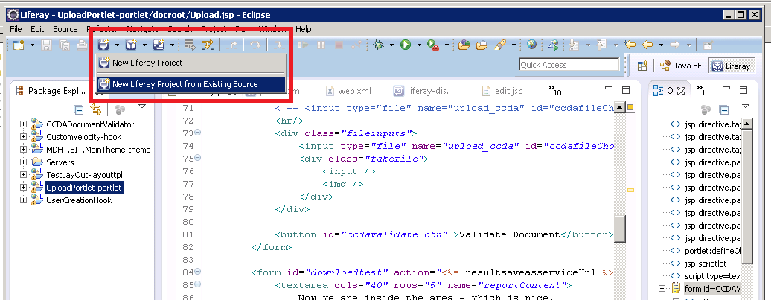

1. Two ways to deploy the portlet:

Regular deployment: drag and drop the project node from the Package explorer to the LifeRay 6.1 server node:

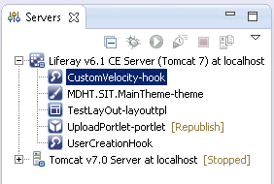

Hot deployment: have the LifeRay instance running (startup with batch file) then right click on project,

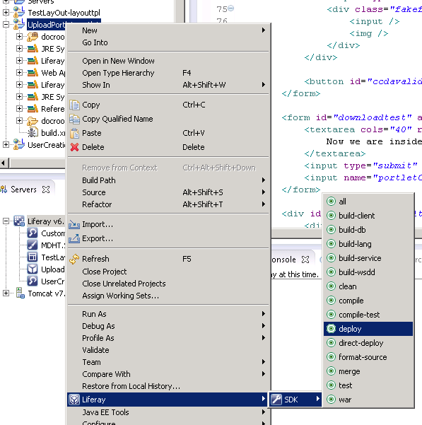

10 Life configurations,

By Default, Life Ray will use its own imbedded database, if you want to connect an external database a properties file needs to be created, and the file requires to be placed at the following location:

{LIFERAYHOME}\tomcat-7.0.27\webapps\ROOT\WEB-INF\classes\portal-ext.properties

Here is the example of the configuration for the production environment:

<https://dl.dropboxusercontent.com/u/32183451/portal-ext.properties>